**USING RAPTOR – AMSTRONG NUMBER OR NOT**

**FLOWCHART**

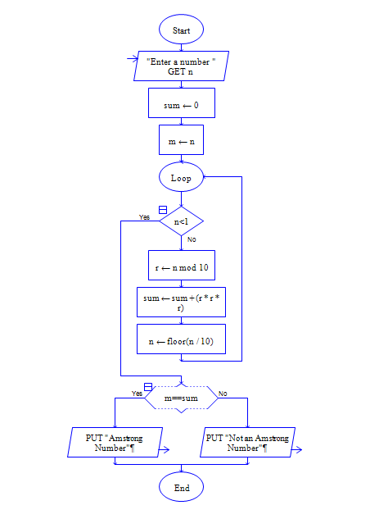

**INPUT**

153

**OUTPUT**

